A000-INDO-Dayak-Female Guardian of Menses Hut-Hornbill Bird above-Panel Stone-19th c

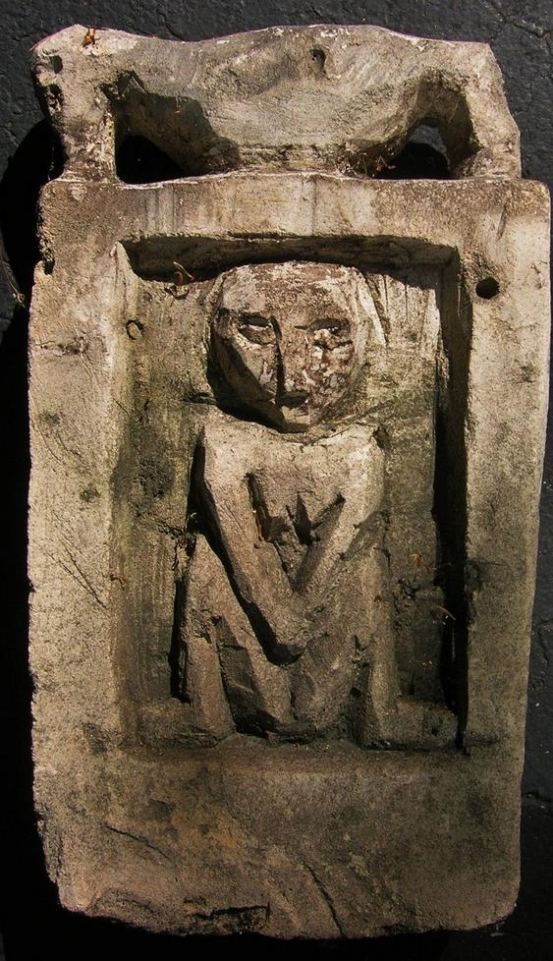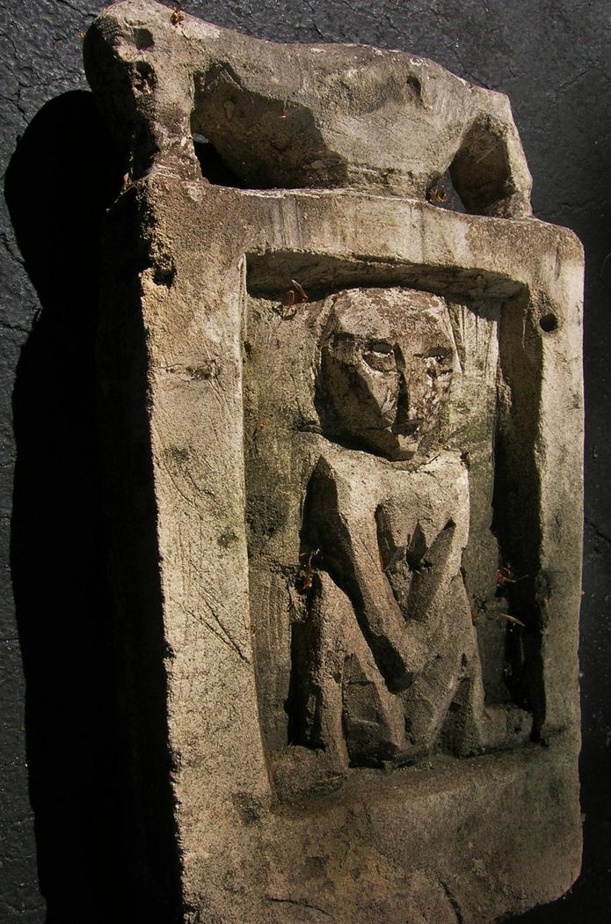

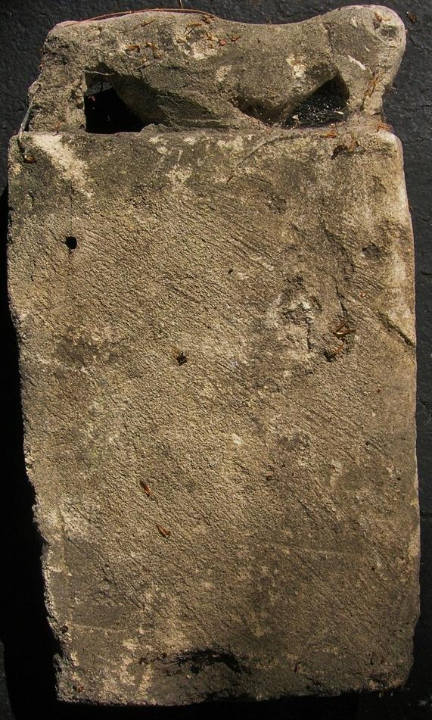

Figs. 1-3. INDO-Dayak-Female Guardian of Menses Hut-Hornbill Bird above-Panel Stone-19th c

**Accession No.**

**Formal Label:** INDO-Dayak-Female Guardian of Menses Hut-Hornbill Bird above-Panel Stone-19th c

**Display Description:**

Dayak stone apotropaic menses hut panel. This figure shows a female guardian of the menses hut for girls entering womanhood. The hornbill bird above indicated a symbol of fertility. This plaque would have been fastened on the hut through the attachment holes shown on the reverse.

**LC Classification:**

**Date or Time Horizon: c 1910**

**Geographical Area:**

**Map:**

**GPS coordinates:**

**Cultural Affiliation:**

**Media:**

**Dimensions:** 15 inches tall

**Weight:**

**Condition:**

**Provenance:** Ex Bourke Estate, New York City, 2014.

**Discussion:**

**References:**

Sold by [primitifstuff](http://myworld.ebay.com/primitifstuff) ( [1787](http://feedback.ebay.com/ws/eBayISAPI.dll?ViewFeedback&userid=primitifstuff) )

### Delivery package 1 of 1

Estimated delivery Friday, Oct 9, 2015 - Tuesday, Oct 13, 2015

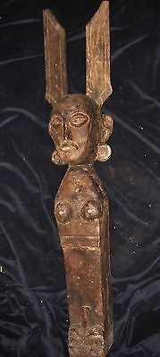

#### [NIAS UMA FIGURE 35"](http://www.ebay.com/itm/221898123140)

|  |  |
| --- | --- |
| Item price | $89.99 |
| Quantity | 1 |
| Item number | 221898123140 |
| Shipping service | USPS Priority Mail |

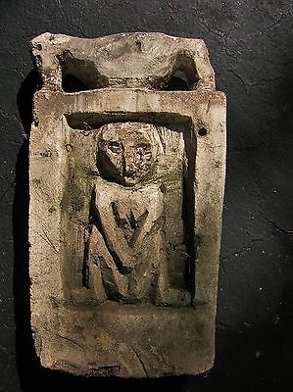

#### [DAYAK STONE PROTECTIVE FIGURE 15"](http://www.ebay.com/itm/221898141111)

|  |  |
| --- | --- |
| Item price | $79.99 |
| Quantity | 1 |
| Item number | 221898141111 |
| Shipping service | USPS Priority Mail |